1. In earlier lecture, we discussed loose coupling and we were creating object with keyword new and those objects are stored in HEAP Memory in JVM.
2. **Issue**: In real-life project, usually we may have a huge number of classes and creating objects manually with keyword new is not that efficient.
3. **Solution**: Here comes the Spring IoC Container which can create those classes objects automatically and can manage their lifecycle.
4. **IoC**: Inversion of Control.   
   Basically, we are taking the control of creating objects from Developers and giving it to Spring IoC.   
   These objects created by IoC are called **Spring Beans.**
5. **Spring Beans:** Simple Java Objects created by Spring IoC Container and whose lifecycle is managed by it.
6. Different Types of DI.  
   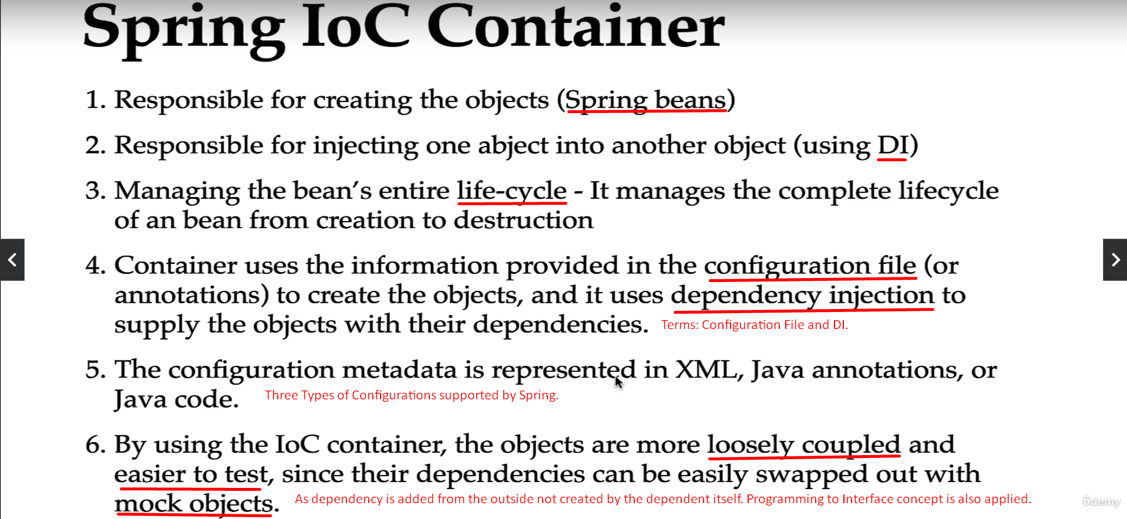
7. 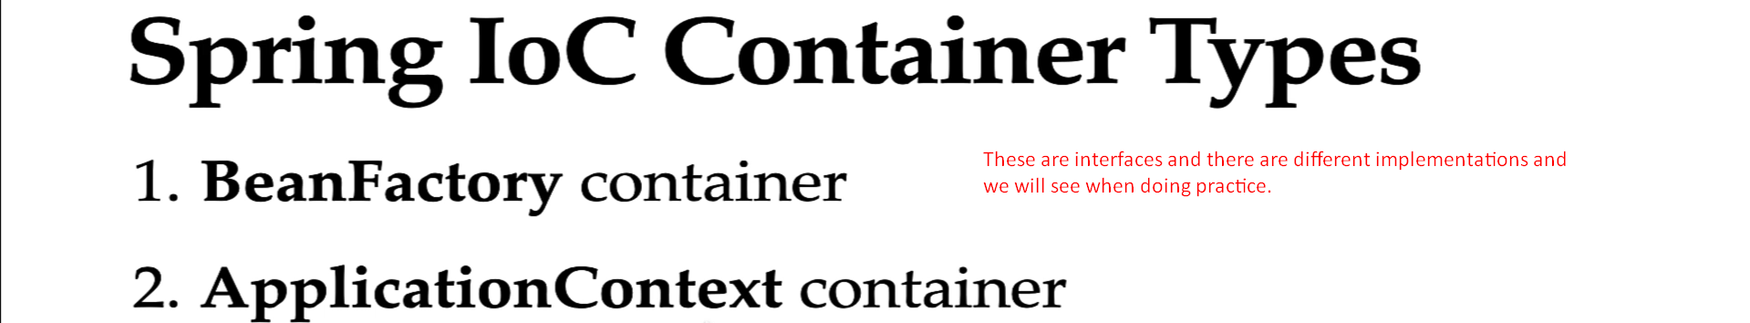
8. 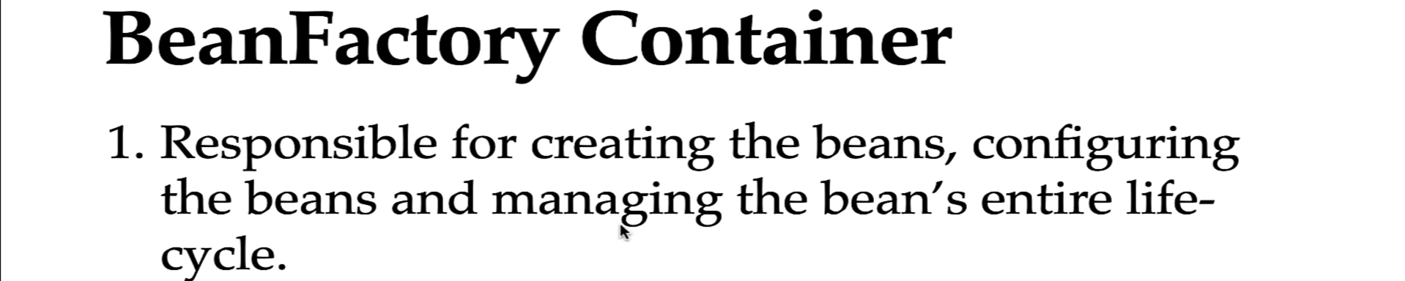
9. 